A

Technical Report

on

**SMART HELMET WITH ALCOHOL DETECTION**

*Submitted to CMR Institute of Technology in the partial fulfillment of the requirement of*

**Social Innovation Lab**

Of

**II B.Tech I- Semester**

in

**ECE DEPARTMENT**

Submitted by

**KALIKIRI GOWTHAMI (20R01A0429)**

**KOMURAVELLY AMULYA (20R01A0436)**

**SAMA SAIRAM (21R05A0401)**

**ALUGURI SAIRAM (21R05A0402)**

**PURELLY LINGAM REDDY (21R05A0403)**

***Under the esteemed guidance of***

*Mrs.K.Neelima*

*Assistant Professor*



**CMR INSTITUTE OF TECHNOLOGY**

**(UGC-AUTONOMOUS)**

(Approved by AICTE, Permanently Affiliated to JNTU Hyderabad, Accredited by NBA, Accredited by NAAC with A Grade)

Kandlakoya (V), Medchal Road, Hyderabad 501 401

**2021-2022 1**

***Department of ECE***

**Certificate**

This is to certify that the technical report entitled as “ **SMART HELMET WITH *ALCOHOL DETECTOR***” is the bonafide work done and submitted by

**KALIKIRI GOWTHAMI (20R01A0429)**

**KOMURAVELLY AMULYA (20R01A0436)**

**SAMA SAIRAM (21R05A0401)**

**ALUGURI SAIRAM (21R05A0402)**

**PURELLY LINGAM REDDY (21R05A0403)**

towards the partial fulfillment of the requirement of Social Innovation (SIL) Laboratory of **II B. Tech I-Semester** in **ECE** is a record of bonafide work carried out by them during the period **Aug 2021 to Jan 2022.**

**Guide Co- Ordinator Head of Department**

***Mrs.K.NEELIMA Mr.P.Nagaraja kumar Dr. Niranjan Reddy***

**INDEX**

**Topics Page No**

**CHAPTER-I INTRODUCTION 4-5**

**CHAPTER -II Empathize 6**

**CHAPTER -III Define**  **7**

**CHAPTER -IV Ideate 8-9**

**CHAPTER -V Prototype 10-17**

**CHAPTER -VI Test 17-20**

1. **INTRODUCTION**

* **WHAT IS SOCIAL INNOVATION?**

The term ‘social innovation ’once rarely heard is , now often used to describe a whole variety of things that fall into general categories of being both new and good. It’s understandable that the phrase has become popular-we get excited and hopeful when it seems possible for real change to happen in the world.

Social innovation refers to the Design and implementation of new solutions that imply conceptual ,process ,product or organisational change which ultimately aim to improve the welfare and well being of individual communities.

Social innovation is not a new concept and should not be considered similar to other definitions, such as social entrepreneurship, creativity or invention, improvement or change. 'As with innovation in technology or business, social innovation is distinct from ‘improvement’ or ‘change’ and from ‘creativity’ and ‘invention’. These last two are both crucial to innovation but overlook the important stages of implementation and diffusion which make new ideas useful.

* **What is design thinking process?**

Design Thinking is a design methodology that provides a solution-based approach to solving problems. It’s extremely useful in tackling complex problems that are ill-defined or unknown, by understanding the human needs involved, by re-framing the problem in human - centric ways, by creating many ideas in brainstorming sessions, and by adopting a hands-on approach in prototyping and testing. Understanding these five stages of Design Thinking will empower anyone to apply the Design Thinking methods in order to solve complex problems that occur around us — in our companie in our countries, and even on the scale of our planet. 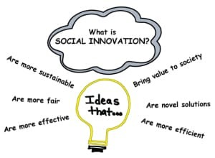

Design thinking originally came about as a way of teaching engineers how to approach

problems creatively, like designers do. One of the first people to write about design

thinking was John E. Arnold, professor of mechanical engineering at Stanford

University.

**The five stages of design thinking:**

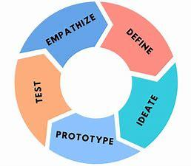

1. Empathize-The Design Thinking process starts with empathy. In order to create desirable products and services, you need to understand who your users are and what they need.
2. Define- In the second stage of the Design Thinking process, you’ll define the user problem that you want to solve.
3. Ideate.-The third stage in the Design Thinking process consists of ideation or generating ideas. ...
4. Prototype- In the fourth stage of the Design Thinking process, you’ll turn your ideas from stage three into prototypes.
5. Test -The fifth step in the Design Thinking process is dedicated to testing: putting your prototypes in front of real users and seeing how they get on.

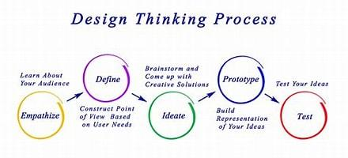

**1. EMPATHIZE**

The first stage of the Design Thinking process is to gain an empathic understanding of

the problem you are trying to solve. This involves consulting experts to find out more

about the area of concern through observing, engaging and empathizing with people to

understand their experiences and motivations, as well as immersing yourself in the

physical environment so you can gain a deeper personal understanding of the issues

involved. Empathy is crucial to a human-centered design process such as Design

Thinking, and empathy allows design thinkers to set aside their own assumptions about

the world in order to gain insight into users and their needs.

We have collected information from various sources like conducting surveys among the

people about their problems as they are facing right now and interviewing people, reading

novels from various books ,collecting information from the internet.

As our team has conducted a survey among the people at the current problems they are

facing we have got many problems to be listed .In those information we have found many

valid problems as they are facing in the day to day life and the collected information have

been segregated accordingly.

We have shortlisted few problems which are being affected by the most people in the

society.

So , have chosen one of the problem that is the not wearing helmet , drunk and drive

problem from the shortlisted problems that many people are facing.

**2.DEFINE**

In this define stage, we have defined the problem statement accordingly to our problem.

According to the scenario as we have collected information in the empathy stage we have

defined the problem statement as “smart helmet with alcohol detector” we have come to

this conclusion because as per the survey we have conducted, people stated that this a

major problem that should be considered it might look simple but as you can see driving

without helmet. And drunk and drive is a major problems this may lead to accidents on

road if helmet is used by the rider and pillion so cause of head injure may decrease

Drunk and drive is the major problem which may cause to major accidents and driving

the motorcycle without helmet when rider is drunk it not only cause accident but also it

cause loss of life.

It is illegal to drive when you are drunk and not wearing helmet the national crime

records bureau (NCRB) reports that just between 2018 and 2020 drunk driving led to

over 38,000 road accidents that is around 2%of all the road accidents that happened in

India . And, in 2019 alone accidents, while 6,675were seriously injured.

**3. IDEATE**

#### In design In this thinking process we have ideate as the next stage and we have come up

#### with a solution according to the above problem statement as we have mentioned.

The Arduino UNO board is connected to the bluetooth module along with a relay. So we

require some components. So , basically we can create execution model using the arduino

UNO controller which consists of ATmega328P.

Arduino is an open source electronic platform based on easy to use hardware and

software. Arduino boards are able to read inputs -and turn it into an output. The arduino

UNO board is primarily used over other arduino products.

We can use Arduino software for constructing the code and uploading the code to

Arduino.

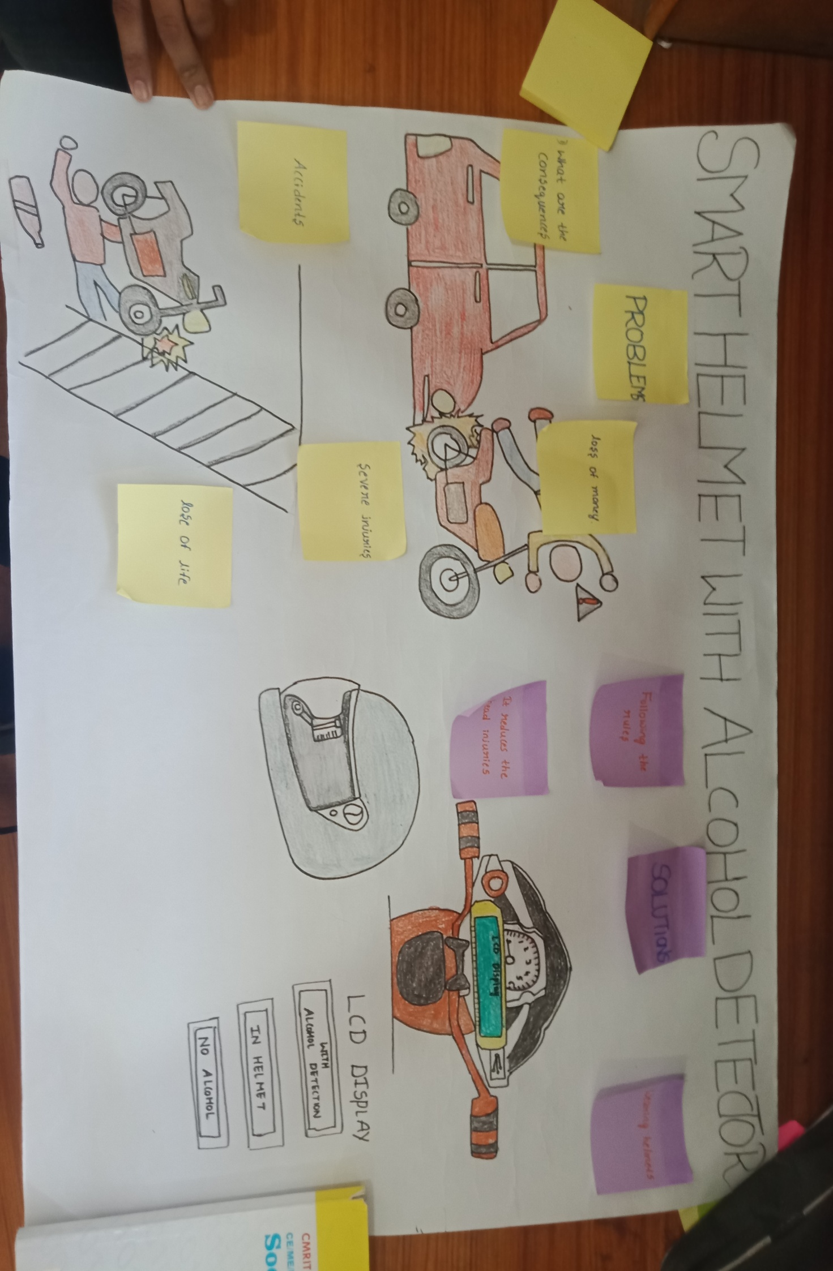

**4. PROTOTYPE**

The next step is making a prototype , that is for making a prototype we require

components like

Table 1. List of required components,

Equipment Quantity

Arduino Uno 1

LCD 1

I2C module  1

Ignition key 1

IRF540n 1

Motor 1

IR sensor 1

Mq3 alcohol sensor 1

Zigbee transceiver module 1

Before starting we will first understand

**About the components:**

ARDUINO UNO:

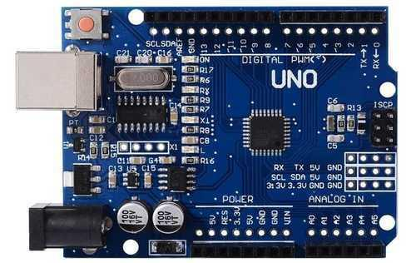

* This is a programming board which is universally used for embedded system

project programming.

* It has 6 analog pins and 13 digital pins. Out of these digital pins, 6 pins are PWM

inputs.

* The programming is done under arduino software.
* The program is important in any of the IC s among these Atmega 329, Atmega
* 168 etc….according to memory requirements by using these board.

LCD MODULE:

A liquid-crystal display (LCD) is a flat-panel display or other electronically modulated optical device that uses the light-modulating properties of [liquid crystals](https://en.wikipedia.org/wiki/Liquid_crystal). Liquid crystals do not emit light directly, instead using a [backlight](https://en.wikipedia.org/wiki/Backlight) or [reflector](https://en.wikipedia.org/wiki/Reflector_(photography)) to produce images in color or [monochrome](https://en.wikipedia.org/wiki/Monochrome). LCD’s are available to display arbitrary images (as in a general-purpose computer display) or fixed images with low information content, which can be displayed or hidden, such as preset words, digits, and [7-segment](https://en.wikipedia.org/wiki/7-segment) displays, as in a [digital clock](https://en.wikipedia.org/wiki/Digital_clock). The use the same basic technology, except that arbitrary images are made up of a large number of small [pixels](https://en.wikipedia.org/wiki/Pixel), while other displays have larger elements.

LCD’s are used in a wide range of applications including [computer monitors](https://en.wikipedia.org/wiki/Computer_monitor), [televisions](https://en.wikipedia.org/wiki/Television), [instrument panels](https://en.wikipedia.org/wiki/Dashboard), [aircraft cockpit displays](https://en.wikipedia.org/wiki/Flight_instruments), and indoor and outdoor signage. Small LCD screens are common in portable consumer devices such as [digital cameras](https://en.wikipedia.org/wiki/Digital_camera), [watches](https://en.wikipedia.org/wiki/Watch), [calculators](https://en.wikipedia.org/wiki/Calculator), and [mobile telephones](https://en.wikipedia.org/wiki/Mobile_telephone), including [smart phones](https://en.wikipedia.org/wiki/Smartphone). LCD screens are also used on [consumer electronics](https://en.wikipedia.org/wiki/Consumer_electronics) products such as DVD players, video game devices and [clocks](https://en.wikipedia.org/wiki/Clock). LCD screens have replaced heavy, bulky [cathode ray tube](https://en.wikipedia.org/wiki/Cathode_ray_tube) (CRT) displays in nearly all applications. LCD screens are available in a wider range of screen sizes than CRT and [plasma displays](https://en.wikipedia.org/wiki/Plasma_display), with LCD screens available in sizes ranging from tiny [digital watches](https://en.wikipedia.org/wiki/Digital_watch) to huge, big-screen [television sets](https://en.wikipedia.org/wiki/Television_set).

Since LCD screens do not use phosphors, they do not suffer [image burn-in](https://en.wikipedia.org/wiki/Screen_burn-in) when a static image is displayed on a screen for a long time (e.g., the table frame for an aircraft schedule on an indoor sign). LCD’s are, however, susceptible to [image persistence](https://en.wikipedia.org/wiki/Image_persistence). The LCD screen is more energy-efficient and can be disposed of more safely than a CRT can. Its low electrical power consumption enables it to be used in [battery](https://en.wikipedia.org/wiki/Battery_(electricity))-powered [electronic](https://en.wikipedia.org/wiki/Electronics) equipment more efficiently than CRTs can be. By 2008, annual sales of televisions with LCD screens exceeded sales of CRT units worldwide, and the CRT became obsolete for most purposes.

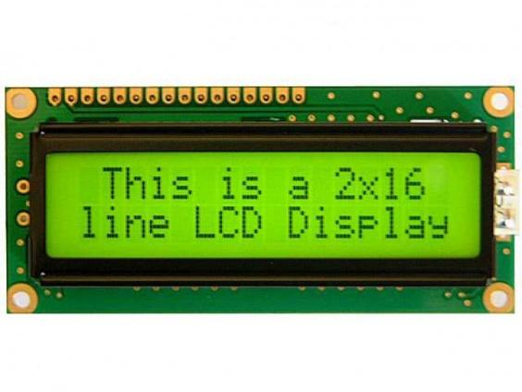

ALCOHOL SENSOR

An alcohol sensor detects the attentiveness of alcohol gas in the air and an analog voltage is an output reading. The [sensor can activate at temperatures](https://www.elprocus.com/temperature-sensors-types-working-operation/) ranging from -10 to 50° C with a power supply is less than 150 Ma to 5V. The sensing range is from 0.04 mg/L to 4 mg/L, which is suitable for breathalyzers.

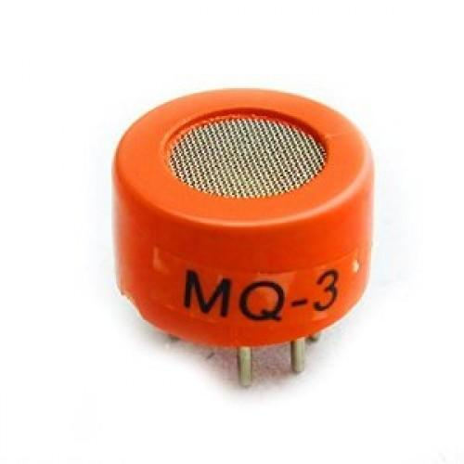

IR SENSOR MODULE:

Infrared Obstacle Sensor Module has built in IR transmitter and IR receiver that sends out IR energy and looks for reflected IR energy to detect presence of any obstacle in front of the sensor module. The module has on board potentiometer that lets user adjust detection range. The sensor has very good and stable response even in ambient light or in complete darkness.

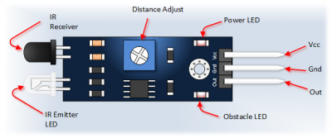

WORKING PRINCIPLE OF IR SENSOR

An IR sensor consists of an IR LED and an IR Photodiode; together they are called as Photo–Coupler or Opt–Coupler. As said before, the Infrared Obstacle Sensor has built-in IR transmitter and IR receiver. Infrared Transmitter is a light emitting diode (LED) which emits infrared radiations. Hence, they are called IR LED’s. Even though an IR LED looks like a normal LED, the radiation emitted by it is invisible to the human eye. Infrared receivers are also called as infrared sensors as they detect the radiation from an IR transmitter. IR receivers come in the form of photodiodes and phototransistors. Infrared Photodiodes are different from normal photo diodes as they detect only infrared radiation. When the IR transmitter emits radiation, it reaches the object and some of the radiation reflects back to the IR receiver. Based on the intensity of the reception by the IR receiver, the output of the sensor is defined.

ZIGBEE TECHNOLOGY:

Zigbee is an IEEE 802.15.4-based specification for a suite of high-level communication protocols used to create personal area networks with small, low-power digital radios, such as for home automation, medical device data collection, and other low-power low-bandwidth needs, designed for small scale projects which need wireless connection. Hence, Zigbee is a low-power, low data rate, and close proximity (i.e., personal area) wireless ad hoc network.

The technology defined by the Zigbee specification is intended to be simpler and less expensive than other wireless personal area networks (WPANs), such as Bluetooth or more general wireless networking such as Wi-Fi. Applications include wireless light switches, home energy monitors, traffic management systems, and other consumer and industrial equipment that requires short-range low-rate wireless data transfer.

Its low power consumption limits transmission distances to 10–100 meters line-of-sight, depending on power output and environmental characteristics. Zigbee devices can transmit data over long distances by passing data through a mesh network of intermediate devices to reach more distant ones. Zigbee is typically used in low data rate applications that require long battery life and secure networking (Zigbee networks are secured by 128 bit symmetric encryption keys.) Zigbee has a defined rate of 250 kbit/s, best suited for intermittent data transmissions from a sensor or input device.

**Programming code:**

Helmet (TRANSMITTER SECTION):

/**/**SMART HELMET WITH ALCOHOL DETECTION TX int h=7; int a=5;voidsetup(){ Serial.begin(9600); pinMode(h,INPUT); pinMode(a,INPUT);

} void loop(){

if((digitalRead(h)==HIGH)&&(digitalRead(a)==LOW)) Serial.print('a'); if((digitalRead(h)==HIGH)&&(digitalRead(a)==HIGH)) Serial.print('b'); if((digitalRead(h)==LOW)&&(digitalRead(a)==LOW)) Serial.print('c'); if((digitalRead(h)==LOW)&&(digitalRead(a)==HIGH))

Serial.print('d');

}

Bike (RECEIVER SECTION):

#define sw A0;

int motor = 3;

#include <LiquidCrystal_I2C.h>

LiquidCrystal_I2C lcd(0x27,20,4);

void setup()

{

lcd.begin(16, 2);

lcd.backlight();

Serial.begin(9600);

pinMode (motor, OUTPUT);

digitalWrite(motor, LOW);

lcd.setCursor(0, 0);

lcd.print("SMART ");

lcd.setCursor(0, 1);

lcd.print("HELMET ");

delay(5000);

lcd.clear();

lcd.setCursor(0, 0);

lcd.print(" WITH ");

lcd.setCursor(0, 1);

lcd.print("ALCOHOl DETECTION ");

delay(5000);

lcd.clear();

}

void loop()

{

if (Serial.available())

{

char zb = Serial.read();

if (zb == 'a')

{

lcd.setCursor(0, 0);

lcd.print("NO HELMET ");

lcd.setCursor(0, 1);

lcd.print("ALCOHOL DETECTED");

digitalWrite(motor, LOW);

}

else if (zb == 'b')

{

lcd.setCursor(0, 0);

lcd.print("NO HELMET ");

lcd.setCursor(0, 1);

lcd.print("NO ALCOHOL ");

digitalWrite(motor, LOW);

}

else if (zb == 'c')

{

lcd.setCursor(0, 0);

lcd.print("IN HELMET ");

lcd.setCursor(0, 1);

lcd.print("ALCOHOL DETECTED");

digitalWrite(motor, LOW);

}

else if (zb == 'd')

{

lcd.setCursor(0, 0);

lcd.print("IN HELMET ");

lcd.setCursor(0, 1);

lcd.print("NO ALCOHOL ");

digitalWrite(motor, HIGH);

}

}

}

**5. TEST**

We have tested the smart helmet many with alcohol detector per the convinence and the usage and we have changed the working models as per the requirement and made a final model .

And code that works more efficiently than any other we have debug the few errors and we have sloved all the problem which is frequently occurring. I have found many solutions which made me easy to slove and debug the things which made us trouble .

And the thing here is that the connections should be very appropriate if fails to put the connections properly he cant go further in the project every connection has its own function. And also check the connections twice or thrice whether the vcc is and ground is properly fixed or not . Coming to the signal pins or pulse width modulation pins and analog pins we are used to 12 connect according to the code that we have given to the Arduino other wise the code doesn’t work .

Testing the setup ‘n’ number of times will make us to clear all the loop holes which are in it . And the final product is efficient and its performance is good and considerable.

And while uploading the code make sure you are connected to the port and upload it .

**CIRCUIT DIAGRAM**

**TRANSMITTER SECTION**

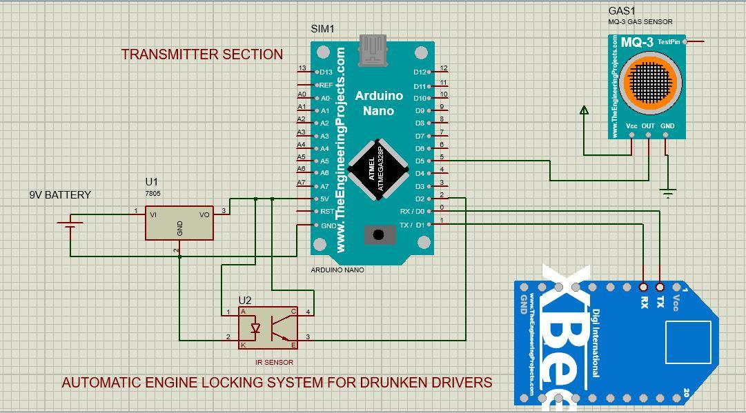

**RECEIVER SECTION**

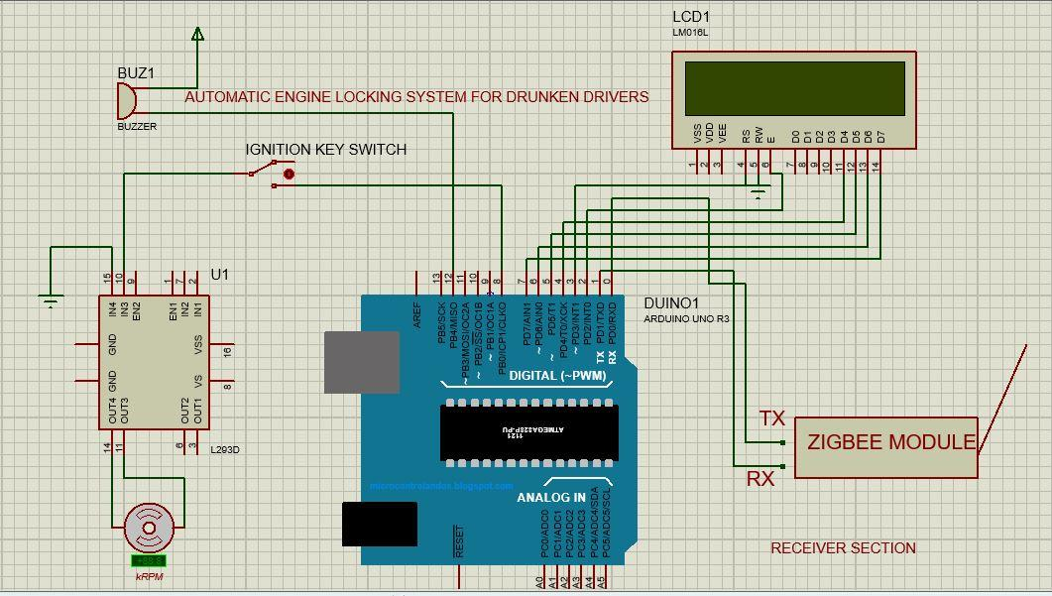

**WORKING PRINCIPLE**

* This system consists of mainly two hardware parts.
* Transmitter section comprises of helmet in which IR sensor and alcohol sensor are placed.
* In receiver section a ATMEGA 328P microcontroller is used which will receive the signals through ZIGBEE trans receiver.
* Here we designed a system which checks the two conditions before ignition of the engine. The first condition is whether the rider is wearing helmet or not and it is detected by a IR sensor.
* The second condition is detection of alcohol content in rider's breath with the help of an alcohol sensor.
* If the rider is wearing helmet and the alcohol content is not detected then ignition of engine starts.
* if the rider is wearing the helmet system checks for content of alcohol in rider's breath using an alcohol sensor MQ3.
* In case the alcohol content is not detected ATMEGA microcontroller receives data from these sensors and gives digital data to the ZIGBEE transmitter connected to it.

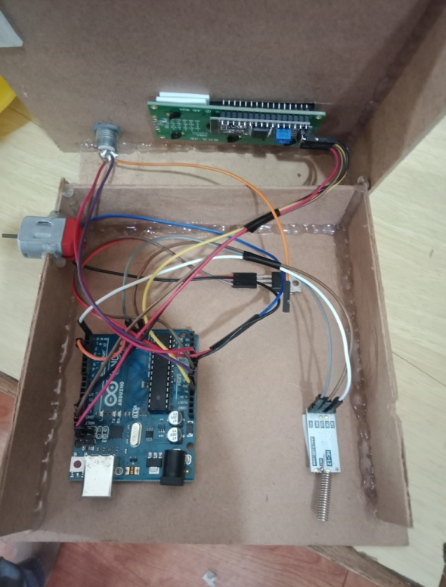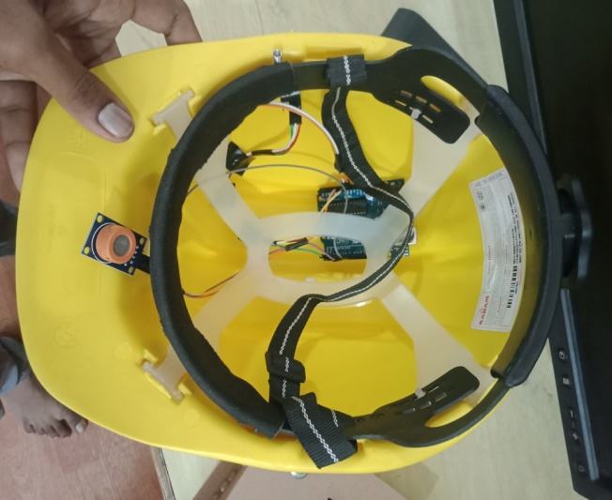

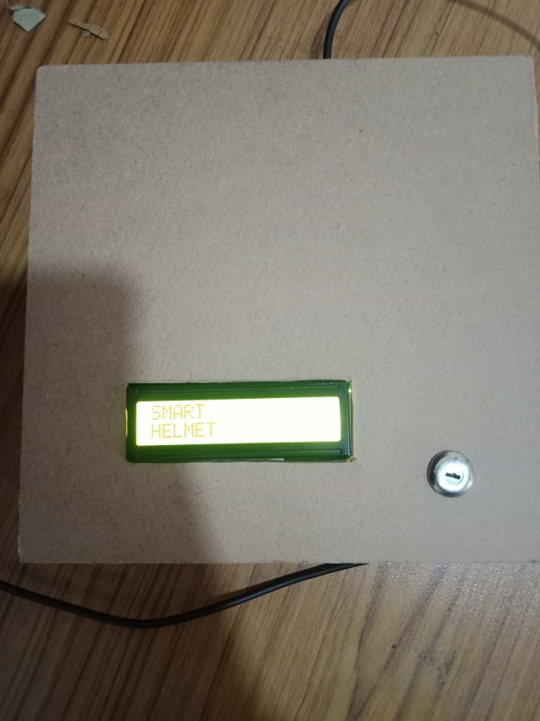 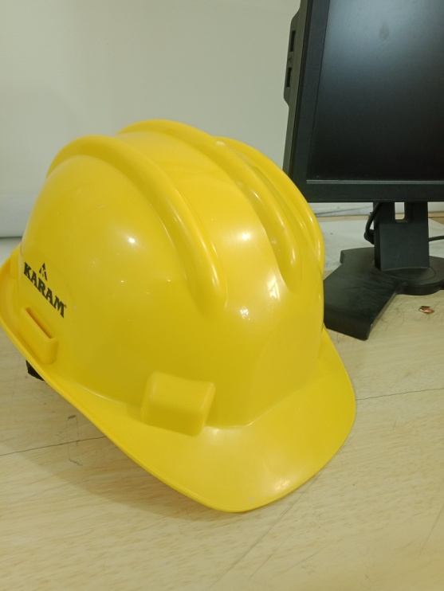

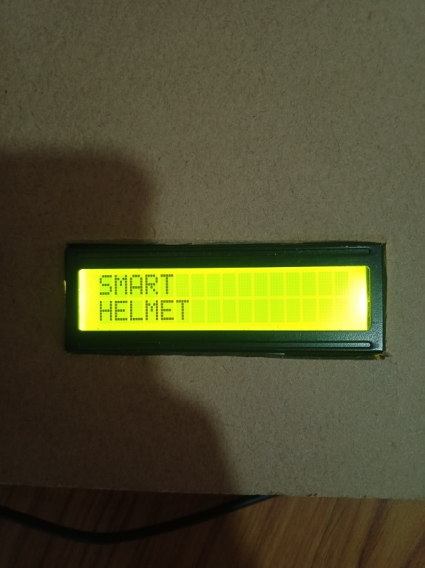 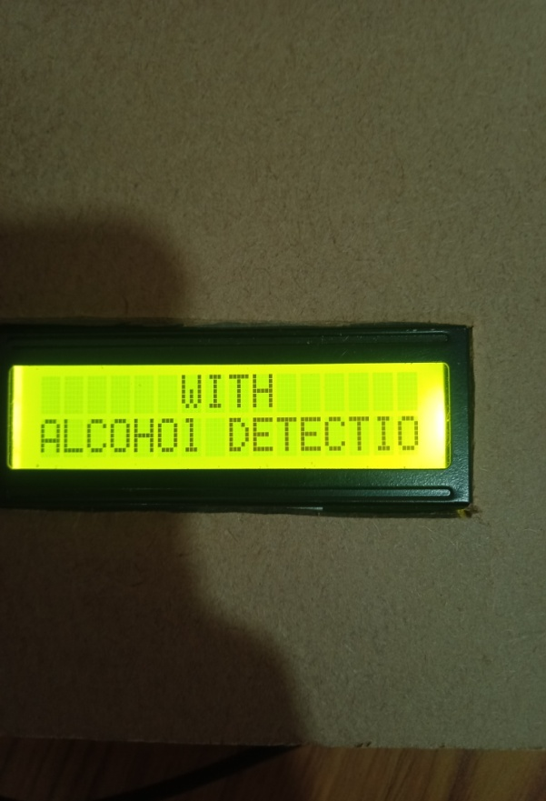

**CONCLUSION:**

Nowadays, most cases of accidents area unit by motor bikes. The severities of those accidents are increased because of the absence of helmet or by the usage of alcoholic drinks. In our project we have a tendency to develop an electronic intelligent helmet system that efficiently checks the wearing of helmet and drunken driving. By implementing this system a safe 2 wheeler journey is possible which would decrease the head injuries throughout accidents caused from the absence of helmet and additionally reduce the accident rate due to drunken driving.

**REFERENCE:**

Internet .

Arduino uno info.

<https://www.arduino.cc/en/guide/introduction>

Social innovation textbook.

Embedded c programming basics.

<https://www.electronicshub.org/basics-of-embedded-c-program/>

<https://github.com/fdebrabander/Arduino-LiquidCrystal-I2C-library>

<https://www.fierceelectronics.com/sensors/what-ir-sensor>

<https://components101.com/sensors/mq-3-alcohol-gas-sensor>